Revisiting a Text

How to get Repetitions in Upper Levels
Without being Repetitious

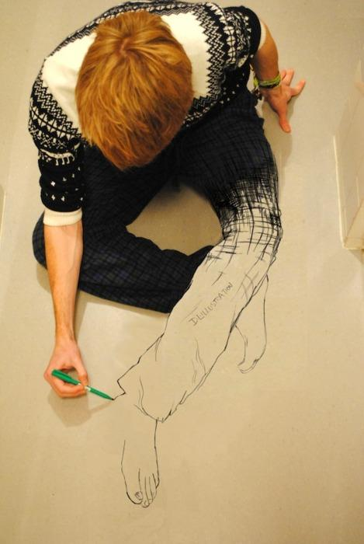

COACH Fall Workshop
03 November 2018
Robert Harrell herr.harrell@gmail.com
Tina Livingstone tlivingstone4@gmail.com

Revisiting a Text
How to Get Repetitions without Being Repetitive

Featured Strategies and Practices

- Draw the character: The teacher reads the description of a main character from the story, and students draw what they hear and identify the character. Later, the teacher reads the description of another, while students draw what they hear. Students then compare their two drawings and discuss.
- Variant 1: The teacher gives out two different written descriptions, one to one half of the class and the other to the other half of the class. Students draw their character as classwork or homework. Then they describe their drawing to a partner, who draws that character. Once both students have drawn the character their partner described, they compare the drawings and discuss. The entire class can discuss the drawings as well.
- Variant 2: This is similar to variant one, but instead of giving written descriptions, the teacher divides the class in half. An advanced student, a colleague, a student teacher, or other good reader reads to one group of students while the teacher (or another person) reads to the other half of the class. Readers repeat as often as necessary until the students have finished drawing the character. Then students work with a partner as in variant 1.
- Variant 3: For teachers with good technology skills. The teacher records the two different character descriptions. Students are assigned to listen to one or the other as homework or classwork. They may repeat the description as often as needed to finish the drawing. Then they work with a partner as in variant 1.

2. Fishbowl (Oral)

3. Secret Thoughts (toward the end of the story):
- Teacher provides several statements that individual characters might be thinking at different points in the story. Students identify which character would be thinking this and when.
- Students create their own secret thoughts and test a partner or the class.

4. Gallery Walk
- Students are given time in class (or a homework assignment) to pick an event that occurred in a literary work. The teacher can divide the class into chapters, paragraphs, or time periods depending on the reading. In this way not all the students will be picking the same event.
- Students are asked to draw the event on a white sheet of paper. They are also asked to explain in four or five sentences what occurred at this event, in other words describe their picture. Depending on if it’s an AP class or a level III class, teacher will decide how much information students can handle. They can write it down if they need to, but they cannot read it, they must be able to glance at notes and explain using the picture that they have drawn.
- When students have finished, you pick half of the students to go around the room and find a spot that will be their space for their picture. Make sure students are spaced with enough room away from other students. I try to have an equal number of students doing each chapter, in other words if there were four students describing chapter three, I would have only two come up first and the other two can come up during the second round.
- Once students are up with their drawings, the other half of the students, the ones that are sitting, go stand next to a student with a picture around the room. Everyone should have at least one person with him/her. Now the Gallery walk begins. Each student that is sharing his/her drawing, describes their picture. The student listening needs to ask at least one question. Have some examples on the board for students to use. They can use What, Why, Where, etc. questions.
- Once the teacher notices that students are starting to quiet down, blow a whistle, ring a bell or turn off the lights, which indicates that it’s time to move clockwise to the next picture or student. Students are now with the next student in the gallery walk.
- Students continue around the room until the teacher feels that students have shared their drawings at least five times. Have students with pictures take down their drawings and now students that listened during the first round will be presenting their drawings. Do the same as with the first group.
- On the board or on a sheet of paper, have some expressions that students could use during the walk. For example: Great job! Beautiful picture. Excellent explanation. I liked your story (ideas, drawings, etc.) Students will use these expressions, and hopefully learn them, if you have them available to use.
- As a debrief, students can go back to their seats and on the back of the picture write out their presentation.

EXPRESSIONS FOR GALLERY WALK (for the listener)
- Can you repeat that last sentence?
- Slower please
- Great Job!
- Beautiful picture
- Excellent explanation
- Thank you for sharing
- I like your… (story, ideas, drawings)
- Bye
EXPRESSION FOR GALLERY WALK (for the presenter)
- Hello
- In this drawing..
- My picture represents…
- Here…
- There is, there are…
- As you can see…
- He/She is wearing…
5. Sentence Match-up:
- Plot detail: Use a list of sentences from the story. Cut out sentence halves and pass out the strips. Students move around the class and read their half of the sentence in order to find the match. Extension: Students line up or form a circle to put the events in order.
- Story sequence: Create a list of events and make copies for as many groups as you wish, then cut each sentence into a strip. Put the strips in an envelope. Each group gets an envelope and at your command puts the events in order. First group with the correct order wins (bragging rights).

6. Oral Story Sequence (Class Oral Review): After reading a literary work, students work together to retell the story using sentences that individual students have presented to the class.
- Teacher explains that volunteer students will present one sentence describing an event that occurred in the reading. Teacher chooses students to say their sentence to the class in a loud voice so that all can hear. Once the first student has said his sentence, he goes to the front of the class.
- Teacher then selects the second volunteer, who tells another action or event in the story. Now students have to place this student horizontally: to the left of the first student, if this event took place before the action of the first student; or to the right of the first student, if the action took place after the first event. In other words students should be in the same order as the story in front of the class, going from left to right.
- When all volunteer students (at least 10) have told a part of the story, and the students agree that the volunteers have been placed in the correct order of the story, then the volunteer to the far left of the class starts the story by saying his sentence. Each student continues by saying his sentence in turn. At the end the students in front have retold the story orally.
- Important Vocabulary for Oral Story Sequence:
_(Student)_ should be to the right of ___
_______ should be to the left of _____
He/She goes before ______
He/She goes after ____
He/She is between ______ and _____
He/She is at the beginning

He/she is in the middle
He/she is at the end
No, not there
No, not like that!
That’s right
Perfect!
We’re done

7. That’s My Opinion: This is a good revisit of a literary work where students can share their opinion about some of the themes that are in a story.
- Have students get into groups of three or four students, depending on the size of your class.
- Pass out a copy of an OPINION LINE to each group.
- Each student will be a letter from A to D or E, if there are five students.
- Teacher passes out a different colored marker to each student in a group. In this way you can tell whose opinion is where on the opinion line.
- Teacher explains that you have five questions for them and that after the teacher has read the question they will have some think time. During this time they will not talk, but think about how they feel about this statement. For example if I were discussing the story “Red Riding Hood”, I could say, All wolves are bad and should be destroyed. After some think time, student will use their marker to show their opinion on the Opinion Line. They can go from strongly agree to strongly disagree or anything in between depending on where they make their mark. Students must all mark the line at the same time. The teacher says ready, set and MARK. Students should mark at the same time so that they are not swayed one way or another by the other students.
- The teacher calls on any of the students (A,B,C or D) to explain their position on the line. Have some sentence starters that students can use on the board to help them answer the questions.
- Teacher can debrief activity by having (volunteer) students explain their opinion to the whole class. You can also find the students that disagree and have different opinions presented.
- After going over the questions, you can use them for a test of that story.
- Useful Vocabulary:
In my opinion… In spite of …
I believe that… Given that…
The truth is… Taking into consideration…
The most important thing is… In the first place…
It’s also important to consider… It’s true (obvious)...

---------------------------------------------------------------------------------------------------------------------
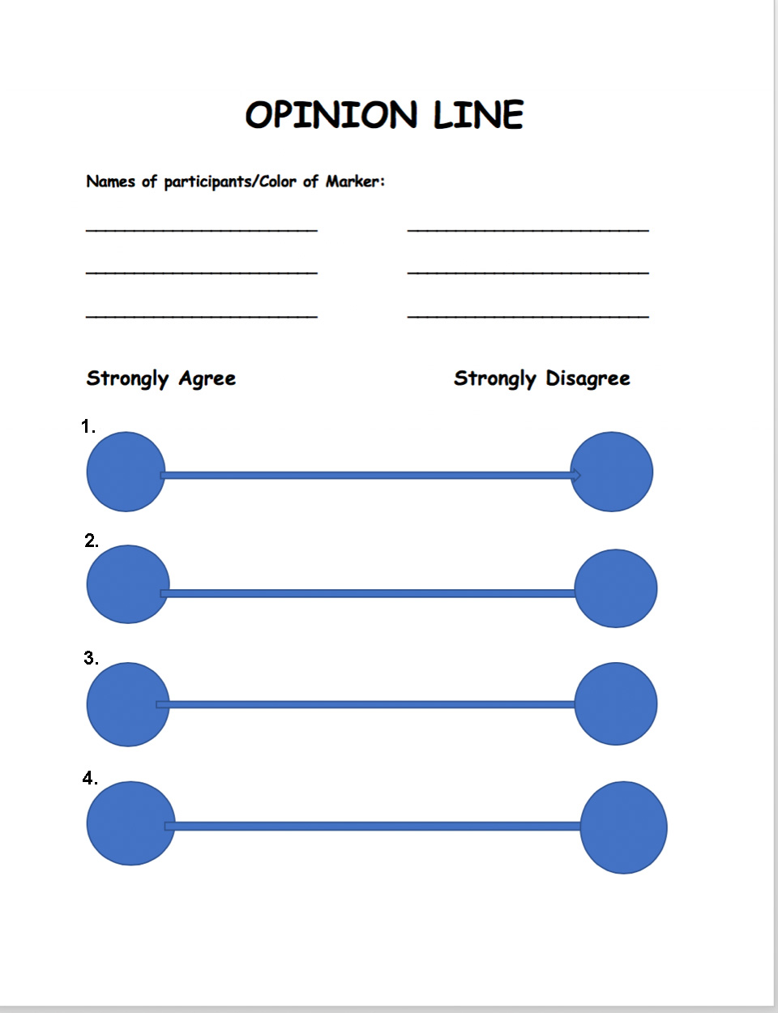

Other Strategies and Practices

Introduction to the text (Into)
1. KHLW: The teacher uses a KHLW chart or other graphic organizer to help students access prior knowledge. Label the chart to align with the text being read (e.g. “Pirates”), then ask students in the target language what they know about the subject. (Questions could include: “When were there pirates?” “Where were there pirates?” “What is the name of a famous pirate?” “Are there pirates today?”) The teacher and students write down the information in the “K” column of the graphic organizer. Students also write down HOW they know what they know the information in the “H” column of the chart. (This column is important because of the wealth of misinformation about many subjects that arises from novels and movies.) Then the teacher shows pictures of the subject (e.g. pirates from different periods in history) and presents a lesson in the target language (e.g. explains that ever since there have been ships, there have been pirates. In the 1300s and 1400s there were many pirates in the North Sea and Baltic Sea.) Students write down information in the “L” column of the chart. Then they write down what they would like to learn about the subject in the “W” column of the chart. The teacher explains that they will be reading a novel about pirates and addresses what sorts of things students will learn as they read and study about pirates.
Pirates

Know | How | Learned | What
What do you know about pirates? | How do you know this? (e.g., movies, books, TV, friends) | What have you learned about pirates from the day’s lesson? | What do you want to know about pirates as we read the pirate book?
2. Vocabulary: It’s important for each teacher to build a vocabulary list that supports learning in his/her classroom. Teach needed vocabulary via TPR, TPRS, songs, etc. before reading the text so that students say to themselves, “Reading is so easy!”
3. Reading a drawing: Before handing out the books, show students (preferably using a document camera and projector) the cover of the book.
- What do they see?
  - Students describe the cover illustration as accurately as possible.
- What is surprising?
  - How is the drawing different from or similar to students’ ideas about the subject?
  - Students discuss their preconceptions versus the drawing
- What do they infer?
  - Students discuss what conclusions they can draw from their observation
- What do they predict?
  - Students make predictions about the nature of the story from the drawing and the title.
- Note: The front and back cover of the book, including any text, can be used for this strategy.

4. Shower Curtain Map: Have an aide draw a map on a shower curtain with permanent marker. Hang the map on the wall before reading to the book to attract student interest. Use the map for various class activities during the reading.

Interacting with the Text (Through)

5. “Sacred” Reading: The teacher reads aloud to students. This can take the form of “Kindergarten Day”, having students follow along with an onscreen image, asking students to read along in their books, etc. The important thing is for the teacher to model “dramatic reading” with inflection, dramatic pauses, gestures and other storytelling devices. Avoid a flat, monotone, boring reading of the text.

6. Dialogic Reading: This is what parents naturally do with their children. It involves reading a text and discussing it with the learner but not in a highly analytical way, more like a conversation about what’s on the page and then going off on tangents and personalizing the conversation.

7. “Independent” Reading: This is, of course, what we want students to do, become independent readers. However, independent doesn’t have to mean solo. Students can read alone, in pairs, and in small groups. The important thing is that they have enough language to understand the text easily. The teacher must choose an appropriate text, not simply one that is prescribed for a particular course.

8. Read and Discuss: The teacher needs to utilize many strategies to engage students while reading and afterwards.
- Create questions to engage students with the story and check for comprehension. I recommend Martina Bex’s excellent work as a reference to help align questions with Common Core. http://martinabex.com/tag/common-core/
- Use true-false questions as warm-up and connecting activities. When giving T/F questions verbally, have the students do something kinesthetic to indicate the answer. Suggestion: Clap twice for True, stomp your feet for False; hold up red or green card; students stand up and move to one side of the room or the other.
- Allow students to create their own T/F questions for the class
- To help students visualize each character in a story, ask them to identify a person in the class who might play this character in the “movie version”; alternatively pick an actor or actress for the part. Students must support their choices with phrases from the story.
- Ask students to compare their lives to the lives of the main characters. Create a “parallel scene” at different points in the story.
- Speech bubbles: Prepare several “speech bubbles” made of cardstock and write a phrase, remark or exclamation from the story (or one that a person from the story’s place and time would use) on each one. More than one bubble may be used for each word, phrase or exclamation. Hand out the speech bubbles to various students. Whenever something in the text needs a response, a student holds up a speech bubble, and the other students say what’s written in their best imitation of someone from the story’s setting or character in the story.
9. Puzzles: Students learn geography as they put together map puzzles and art as they put together puzzles of pieces of artwork connected to the text that they are reading. Students can draw itineraries on the maps they have put together and discuss the art they are viewing. Use maps and artwork that come from the text that students are reading.
10. Readers Theatre: Students perform a segment of the story as a “Readers Theatre”, either TPRS style or traditional.
11. Drama: In addition to Reader’s Theatre, students can read the parts of characters for dialogue that occurs in the book. Students can also “act out” scenes from the book, even having a class competition and giving awards for Best Actor, Best Actress, Best Ensemble, etc.
12. TPR Character ID: The teacher reads a short description or quote from the story, and students show with a TPR motion or gesture which character is being referenced. The teacher can also see how well students make inferences from the book by making statements about what a character would have said or done. The class should create the motion or gesture for each character.

13. Scavenger Hunt: Students look for clues in the text to answer questions that the teacher or other students have created.
14. Character chart: As homework or a warm-up activity, students describe main characters. Students can support their descriptions with a drawing.
Character | Physical | Social | Spiritual
Name of the Character | Physical description of the character, including inferences (e.g. taller than normal, athletic, hair and eye color) | Relationships with other characters; “career” and activities; place in society | Personality; character; significant thoughts and opinions; attitude; life philosophy (often must be inferred)
15. Vocabulary Practice (using vocabulary from the text being read):
- Pictionary: This can be played in small groups or with the whole class divided into two teams. Use whiteboards to draw or small slates for the groups.
- Running Pictionary: Students form teams and sit in rows. The first person in the row faces the teacher. All others face away from the teacher. The teacher writes a vocabulary word on the board or shows it on a projector. The student facing the teacher draws a picture of the word; other students hand the paper as quickly as possible to the last student in the row. The last student writes down the vocabulary word and brings the paper to the teacher. The first team with a correct picture and word gets a point.
- Charades: Divide class in half. Volunteer comes to the front and acts out word/phrase picked from hat. If the team guesses the word in 15 seconds or less, they score a point. If not, the opposing team has 10 seconds to guess and get a point.
16. Running Dictation: Teacher prepares one or more posters of significant quotes from the story and puts them on wall outside of the classroom. Students pair up. One student goes to the poster and reads the quotation, then goes inside and dictates it to the writer. Students may check the poster as often as they wish to be sure they say the quotation correctly. When the students have finished one quotation, they change roles for the next dictation. The runner becomes the writer, and the writer becomes the runner. The first pair to get both (or all) the quotations written down correctly wins.
Note: It is better to hang posters outside the classroom so that the writer is unable to read the poster. Prepare multiple copies of each quotation so that students have easy access to the quotations. It is better to have only one to four quotations. The more quotations there are, the shorter they should be. Depending on room, facilities, and weather, this activity can also be done outside.
17. Flow Chart / Flow Map: Students create a flow chart or flow map of the story.
- Students draw a series of pictures that illustrate the events of the story.
- Students choose the Essential Sentences that tell the story (either of a chapter or of the entire book.) They copy down the Essential Sentences from the text and then create drawing to illustrate the Essential Sentences. The teacher should decide how many Essential Sentences are necessary for the length of the text. (See six-panel storyboard)
18. SQ3R: Students will look at the text several times.
This activity can be done co-temporaneously with other activities. It requires students to Survey, Question, Read, Recite, and Review.
A. Students prepare a template with the following prompts:
a. “Title” (This is the header for the sheet)
b. By: (Author’s name; subheader for the sheet)
c. What is it about? (first question)
d. When and where does the story take place? (second question)
i. When: ii. Where:
ii. N.B.: There can be more than one time and place in a story
e. What is the main problem?
f. How is the main problem resolved or solved?
B. Students survey illustrations, chapter headings, format, etc., then make predictions about the theme, genre, plot, and main character.
C. Students answer the questions with short notes while reading the text.
D. Once they have identified the information and answered the questions through reading, students “recite” by writing down the information and sharing with other students to see if they agree.
E. Students review their information by re-writing the information with complete sentences using the sentence frames provided:
a. The title of the book / story is …
b. The author(s) is (are) …
c. It is about …
d. The story takes place (where) and (when).
e. The main problem is …
f. The main problem is resolved / solved by

Extend the Text (Beyond)
19. Bluffarama: Students write questions and answers and answers about the text. Each student should write one question and answer each for the following: Who? What? When? Where? Why? (Optional) and How? (including: How many? How much? etc.) Teacher collects the questions and answers, then divides the class into two teams. For the first team up, the teacher reads a question at random. Students who are willing to be called on to answer the question stand up. Then someone from the opposing team chooses which of the standing students will answer the question. If the student answers correctly, the first team gets a number of points equal to the number of people standing. If the answer is incorrect, the team loses that many points. The next question goes to the second team. Play alternates until a certain number of points has been reached or time is up.
N.B.: This is an excellent game for a final review of a text or film. The teacher can have students play in German or English, depending on level and ability of the students.

20. Reading and Writing Assessment: Students write a book review / book report in which they demonstrate their writing skills, as well as their comprehension of the book. The writing process should follow these steps:
- Students read the book and do Activity 17: SPQ3R
- Referring to the book and their notes, students do Activity 16: Essential Sentences and Flow Chart / Flow Map
- Using notes from both activities, students write their book review / book report
N.B.: In a multi-level classroom, third-year students might end the assessment with the Essential Sentences and Flow Chart; fourth-year students could write a book report; AP students would write a book review that includes an evaluation of the story and writing as well as a summary of the plot.

21. Journal (Diary) entries: Students take on the persona of one of the characters or someone connected to the characters and write their own diary about the story. This can be done as a single entry for a particular part of the book or as a series of entries throughout the entire book. Especially for the latter, students can create their own book and decorate it appropriately. This becomes a portfolio of student work.
22. Alternatives: Students create an alternative ending or a “missing episode” for the book. Working in groups, they write a skit that shows what happened but wasn’t narrated or what could have happened at the end. Then students present their skit to the class, either live or on video. As part of the preparation, students explain why this is a logical extension of the story.

23. Picture This
- Students read a story, poem, or article.
- Students get into groups of four. Pass out colored markers and butcher paper.
- Students brainstorm and select important vocabulary (nouns, verbs, etc.), phrases, times and places that they remember from reading the story.
- Next, they draw a specific number (decided by teacher) of these selected vocabulary words on the butcher paper. Students may draw pictures in any direction on the butcher paper. Do not label the drawings. When time is called each group then exchanges their butcher paper with another group. Each group will now be working with a different groups’ drawing; not their own.
- Students in their groups first try to figure out what the drawings represent. Then they have about 15 minutes to organize a different story, a poem or to retell the story with a different ending using at least 10 of the vocabulary drawings on the “new” butcher paper. Each student should have only two or three drawings that they will have to use.
- Each member of the group must present one part of the story/poem orally.
  - Students bring their butcher paper with them to the front of the class.
  - As each student presents his/her part of the story, they need to point to the picture on the butcher paper of the word being presented.
  - Students in each group must decide on a title for their story and use transition words to go from one event to the next.
  - This is an oral activity, students do not write out their sentences. Since each student is doing a small part they usually can remember their lines by pointing out the drawings.
- As a next step, the next day have all the poster put around the room and have students label the pictures. Good review of the story and the important vocabulary.

24. Music Video*: Find a video in German of “I’ll Make a Man Out of You” from Mulan.
Here’s one version: http://www.youtube.com/watch?v=uQnhY06g-nU Provide students with written lyrics and check for comprehension. Have students memorize and sing the chorus – why not just have some of them memorize each verse as well as the chorus. Then the class films a music video of the students becoming pirates using the recorded music. Students show their understanding of the clothing, skills, carriage, body language, etc. of pirates. Here are links to lyrics:
http://lyricstranslate.com/en/sei-ein-mann-be-man.html#ixzz2vculyI1s - Translation into German with back-translation into English
http://www.stlyrics.com/lyrics/mulan/illmakeamanoutofyou.htm - original English
25. Write your own lyrics*: This could be done in conjunction with the Music Video or stand on its own. Using the German lyrics, students adapt the song to a pirate’s life: rather than fighting the Huns, they fight the Hansa; rather than getting daughters, the captain got landlubbers; rather than “stark wie ein Taifun”, they should be “stark wie ein Orkan”. Changes can be minimal or extensive, depending on knowledge and talent of students, but should reveal an understanding of the book and the life of a pirate. Students could then record their own version of the song to go with the Music Video.
26. LARP (Live Action Role Playing): This is a step beyond Reader’s Theatre. Students who are interested in this hobby can act out one of the scenes from the book. This can be fairly simple or become quite elaborate, depending on the imagination of the students.
27. Cultural comparisons: Students use a Venn diagram or Double Bubble Thinking Map™ to compare activities and social habits of the characters in the story and those of American teenagers.

28. Solve a Real-World Problem: Students research a real-world problem related to the story or book and then take action to contribute to a solution for the problem. This might be something like exploring disease in third-world countries, wealth inequity, hunger, perceptions of cultural imperialism (the “Coca Cola-isation of the world), etc. The following is one example related to the book Nordseepirat:
The Problem of Hunger*: In Chapter 5 (Gottes Freund …), Geoff participates in a relief effort that occurred in response to a famine in Verden. Famines still occur today in various places throughout the world: Sudan, Somalia, Senegal, Gambia, Niger, Mauritania, Mali, and Burkina Faso have all seen major famines in recent years, and smaller famines occur regularly. While overall famine deaths have declined dramatically in the 21st century, those deaths are now concentrated in Africa. What about hunger in the U.S. and organizations like No Kid Hungry and Share our Strength? Students research the effects of chronic hunger and ways to help, especially in relation to childhood hunger and poverty.
Below are links to information about famine and hunger:
http://feedingamerica.org/hunger-in-america/hunger-facts/child-hunger-facts.aspx
http://www.economist.com/blogs/graphicdetail/2013/05/daily-chart-10
http://www.nokidhungry.org/pdfs/Facts-Childhood-Hunger-in-America-2013-grid.pdf
http://www.worldhunger.org/articles/Learn/child_hunger_facts.htm
http://www.wfp.org/hunger/stats
https://www.freedomfromhunger.org/world-hunger-facts
https://www.nokidhungry.org

29. Historical and Cultural Participation and Research: Choose a project, or menu of projects from which students can choose, to help them connect to the history and culture of story’s location.
30. Breakout: Create a “Breakout” game for students that requires them to re-read portions of the text in order to solve the clues and open the box. The prize in the box could be something that requires further reading.
31. Crime Scene Investigation: This is similar to “Breakout”, but the classroom becomes a “crime scene”, and students investigate the crime, read witness statements and other documents, then file a report with a recommendation for a suspect.

N.B.: All links were correct and functional as of 23 February 2014. Many activities are related directly to the book Nordseepirat (Pirate de la Mer du Nord; Pirata del Norte) but can be adapted to any other story or book that connects to songs or (music) videos that the students know.

Essential Questions
Essential Questions can guide student thinking during reading.
Personal and Public Identities:
How do Geoff’s identity and sense of self change with new circumstances?
How does Störtebeker’s treatment of Geoff compare to his legend?
Is it possible for a “good” person to be “bad” and vice versa?
Beauty and Aesthetics
What does a pirate’s clothing say about him, and how is that clothing perceived by non-pirates?
What role does music play in the life of a pirate?
Families and Communities
How might the pirates be considered a family? What does this say about the nature of family?
How does a stranger fit into a new community?
How does a pirate’s language set him apart or help him fit in?
How and why would a separate “pirate’s language” develop?
Global Challenges
How does the changing political situation affect the lives of the Likedeeler?
How do social issues in Frisia influence political choices and vice versa?
In a complex situation, how can we determine who is right and who is wrong?
Why are the Likedeeler welcomed by the Frisians? What does this say about how communities treat immigrants and why?
What stereotypes and prejudices are revealed, and how do these affect the attitudes and actions of characters in the book?
Science and Technology
How did the technology available affect naval warfare and piracy?
How does the introduction of newer, faster ships into the battle against the Likedeeler compare to a modern arms race?
Contemporary Life
How does a modern teenager’s life compare to that of a medieval cabin boy?
Descriptions:
A man with a fire-red beard comes and looks at Geoff. … He is wearing a hat, a shirt, a vest, a jacket, and a pair of trousers, but no shoes and no socks.
Now Geoff looks like a real cabin boy. He wears long trousers. [The trousers come from the plunder of an earlier naval raid, but] they fit him well. He also wears a linen shirt and a woolen vest[, or he goes shirtless]. On his head he wears a woolen knitted cap. [All of his clothing comes from the plunder. Everything except his board shorts. He wears them under his trousers.] What he doesn’t wear are shoes. Like all the others he goes barefoot.

Name of the Story: ______________________________________

__________________________ _________________________ __________________________
__________________________ _________________________ __________________________ __________________________ _________________________ __________________________
__________________________ _________________________ __________________________ __________________________ _________________________ __________________________ __________________________ _________________________ __________________________

__________________________ _________________________ __________________________
__________________________ _________________________ __________________________
__________________________ _________________________ __________________________
__________________________ _________________________ __________________________
__________________________ _________________________ __________________________ __________________________ _________________________ __________________________
LITTLE RED RIDING HOOD
There was once a sweet little maid who lived with her father and mother in a pretty little cottage at the edge of the village. At the further end of the wood was another pretty cottage and in it lived her grandmother.
Everybody loved this little girl, her grandmother perhaps loved her most of all and gave her a great many pretty things. Once she gave her a red cloak with a hood that she always wore, so people called her Little Red Riding Hood.
One morning Little Red Riding Hood's mother said, "Put on your things and go to see your grandmother. She has been ill; take along this basket for her. I have put in it eggs, butter and cake, and other dainties."
It was a bright and sunny morning. Red Riding Hood was so happy that at first she wanted to dance through the wood. All around her grew pretty wild flowers, which she loved so well and she stopped to pick a bunch for her grandmother.
Little Red Riding Hood wandered from her path and was stooping to pick a flower when from behind her a gruff voice said, "Good morning, Little Red Riding Hood."
Little Red Riding Hood turned around and saw a great big wolf, but Little Red Riding Hood did not know what a wicked beast the wolf was, so she was not afraid.
"What have you in that basket, Little Red Riding Hood?"
"Eggs and butter and cake, Mr. Wolf."
"Where are you going with them, Little Red Riding Hood?"
"I am going to my grandmother, who is ill, Mr. Wolf."
"Where does your grandmother live, Little Red Riding Hood?"
"Along that path, past the wild rose bushes, then through the gate at the end of the wood, Mr. Wolf."
Then Mr. Wolf again said "Good morning" and set off, and Little Red Riding Hood again went in search of wild flowers.
At last he reached the porch covered with flowers and knocked at the door of the cottage.
"Who is there?" called the grandmother.
"Little Red Riding Hood," said the wicked wolf.
"Press the latch, open the door, and walk in," said the grandmother.
The wolf pressed the latch, and walked in where the grandmother lay in bed. He made one jump at her, but she jumped out of bed into a closet. Then the wolf put on the cap which she had dropped and crept under the bedclothes.
In a short while Little Red Riding Hood knocked at the door, and walked in, saying, "Good morning, Grandmother, I have brought you eggs, butter and cake, and here is a bunch of flowers I gathered in the wood."
As she came nearer the bed she said, "What big ears you have, Grandmother."
"All the better to hear you with, my dear."
"What big eyes you have, Grandmother."
"All the better to see you with, my dear."
"But, Grandmother, what a big nose you have."
"All the better to smell with, my dear."
"But, Grandmother, what a big mouth you have."
"All the better to eat you up with, my dear," he said as he sprang at Little Red Riding Hood.
Just at that moment Little Red Riding Hood's father was passing the cottage and heard her scream. He rushed in and with his axe chopped off Mr. Wolf's head. Everybody was happy that Little Red Riding Hood had escaped the wolf.
Then Little Red Riding Hood's father carried her home and they lived happily ever after.

Effective readers use strategies to understand what they read before, during, and after reading;

Before reading, they:
- Use prior knowledge to think about the topic.
- Make predictions about the probable meaning of the text.
- Preview the text by skimming and scanning to get a sense of the overall meaning.
During the reading, they:
- Monitor understanding by questioning, thinking about, and reflecting on the ideas and information in the text.
After reading, they:
- Reflect on the ideas and information in the text.
- Relate to what they have read to their own experiences and knowledge.
- Clarify their understanding of the text.
- Extend their understanding in critical and creative ways.

Think Literacy: Cross-Curricular Approaches, Grades 7-12 www.edu.gov.on.ca/eng/studentsuccess/thinkliteracy/files/reading.pdf

