CONVERSATION CAROUSEL


Conversation Carousel is a alternative to the traditional “in-class presentation” and is an effective and engaging oral assessment activity. Rather than have each student present a memorized monologue in front of the class or individually to the teacher which often takes days of teaching time and allows each student only one opportunity to speak, this format requires all students to repeatedly share their material with many partners, practicing and improving it as they go along. This encourages every student to engage in a meaningful dialogue about personally relevant subjects and permits the teacher to assess their oral fluency while they’re involved in one-on-one conversations with peers. It is much more natural and real world than the traditional presentation.

In addition to providing a very meaningful assessment format, this activity is extremely social and adaptable and be can be used to review information, ask survey questions, or carry on conversations. The strength of the carousel is that students work with and learn from many other students. It also gets them into a new room arrangement and some of them get to move around the room. Encourage students to call each other by name and use social courtesies. (Hi, how are you? Thank you for your ideas. See you next time, etc.) Teachers who are familiar with the “Inner-Outer Circles” strategy will recognize Conversation Carousel as a seated version of the same. It is more effective than Inner-Outer circle when students have a product to share like the T-Shirt activity or Facebook assessment.

When using conversation carousel as an assessment, be sure to use the same format for practice activities prior to the final assessment day. Also, you may want to have the students take notes on the information they learn from their partners.

Students might refer to this activity as “speed dating!” It operates on basically the same principal, lots of personal conversations with many partners during a limited time period.

Purpose: To practice the focus material with many partners

Time: 15-50 minutes, depending on topic and purpose of activity

Arrangements: Arrange desks in pairs with two desks facing each other. If possible arrange these pairs in a circle, or you can just use the normal room arrangement and have students pair off facing each other within that arrangement.

Materials: This activity works best when students have something in hand to talk about. It's a great way to share/present culminating projects or Cultural Participation and Research projects. The teacher needs a timer with a loud bell.

Accountability: Students will be more focused and motivated if they clearly understand how they will be graded or receive points for this activity. Teachers who keep track of participation points on a seating chart will want to circulate, listening to students and marking down points. Another method is to give each student so many colored cards. If they are off task during the activity the teacher merely pulls a card and the student receives one less point than the points possible. Filming the activity, especially if it is an assessment, will definitely
keep the students focused.
The Language Teacher’s Handbook, 1 of 2

Procedure:

Desks/tables: Teach the students how to move the desks into the type of carousel you use. Ideally, there would be an inner circle and an outer circle of desks, each pair of desks facing each other. Most classrooms are not large enough to allow this arrangement and require a snake of paired desks.

Instructions:
1. Students pair off and move desks so that two desks are facing each other. You might allow them to pick their own first partners--they will change many times anyway.
2. Each student should have a card/object/photo to talk about or a note-taking grid.
3. Explain the purpose of the assignment and the specific directions you want followed as well as the accountability system. Tell them how much time they will have with each partner (1-5 minutes).
4. It is extremely important to clearly explain the system of rotation. Usually one side moves and the other side stays put. The teacher can count of the paired desks and show how a student moves from one to the other. Stationary partners should be prepared to guide each partner to the next spot. Skipping this step will lead to a chaotic carousel!
5. Set the timer and the students begin to talk to their partners. Teacher circulates the room taking notes or filming.
6. When time is up, the students facing one direction move one seat over and students do another round with the next partner. Continue in this fashion until students have worked with many partners.
7. If there is time, it can be fun to ask all students to jump up and complete the last rotation with the person of their choice.

Closure: Students will have learned a lot through this activity and will be able to write a lot if given a writing assignment at the end. If a grid is used to fill in information, it becomes the perfect pre-writing note sheet. Students are often very excited at the end of this activity and want to talk about it. Comments like “I didn’t know I could speak Spanish for that long!” and “I actually learned more French from talking to people during this test!” are very common at the end of a Conversation Carousel.

Evaluation: For simple guided-practice activities the teacher may just give a classwork grade of so many points or simply add participation points to the system in place. For assessment projects like MyFacebook.com, the teacher will collect the rubrics and projects and grade them later. Video really helps in this process and some teachers ask an assistant or colleague to do the filming for them for at least part of the activity.

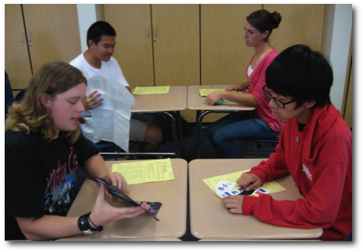
The Conversation Carousel often offers many pleasant surprises. Students are very focused on the conversations and tend to stay in the target language more than in most classroom activities. Students who have never had the chance to converse with each other will make new connections. Planning a conversation carousel early in the term will help build classroom culture.

The Language Teacher’s Handbook, pp. 27-28
COACH - Cynthia Leathers, 2010

