**Staying 90% + in the target language by establishing routines and procedures from day 1**

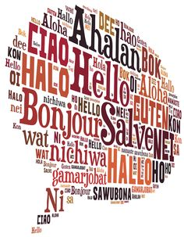

Presented by

Ariene Borutzki and Metzli Webb

**Contact us:** [**Aborutzki@ggusd.us**](mailto:Aborutzki@ggusd.us)[**mwebb@ggusd.us**](mailto:mwebb@ggusd.us)

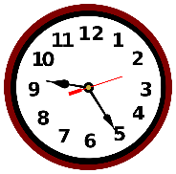

**1. Timing**

* Class minutes x .1
* Slow down
* Repeat
* Point and pause

**2. Prep the walls around your classroom**

* Question words
* Color coded vocabulary (leave it up)
* Circumlocution
* **C:\Users\Metzli\AppData\Local\Microsoft\Windows\Temporary Internet Files\Content.IE5\15SQDK4Z\MCj04238360000[1].wmfC:\Users\Metzli\AppData\Local\Microsoft\Windows\Temporary Internet Files\Content.IE5\TPDNZB8Q\MCj04238600000[1].wmf**Rejoinders

**C:\Users\Metzli\AppData\Local\Microsoft\Windows\Temporary Internet Files\Content.IE5\CSMIQRWO\MCj04258040000[1].wmf3. Greetings at the door**

**4. Date and Weather**

**5. Countdowns**

* How many days are left until summer?
* Which day of school is it today?

**6. Color of the day**

**7. Who is wearing _______?**

**8. Mental breaks in the target language**

**9. Songs – Goodbye**

**C:\Users\Metzli\AppData\Local\Microsoft\Windows\Temporary Internet Files\Content.IE5\80BRRKBB\MCj04238340000[1].wmfC:\Users\Metzli\AppData\Local\Microsoft\Windows\Temporary Internet Files\Content.IE5\PLZPD7KD\MCj04379840000[1].wmfC:\Users\Metzli\AppData\Local\Microsoft\Windows\Temporary Internet Files\Content.IE5\80BRRKBB\MCj04420300000[1].wmf10. Other ideas:**

|  |  |
| --- | --- |
| **Mental Break**  **Las preposiciones usan estar**  **A la izquierda,**  **A la derecha,**  **y empezamos acá.**  **Arriba**  **Abajo**  **Delante**  **Detrás**  **Entre**  **Enfrente**  **Al lado y más**  **Cerca**  **Lejos**  **Aquí**  **Allí**  **Allá** | **Goodbye Song!**  **Hasta luego**  **Hasta mañana**  **Adiós**  **Nos vemos**  **---**  **A bientôt**  **A demain**  **A plus!**  **Au revoir** |