COACH FOREIGN LANGUAGE PROJECT
Eating around the Spanish Speaking World in Southern California
COUNTRY | RESTAURANTS | CONTACT INFORMATION
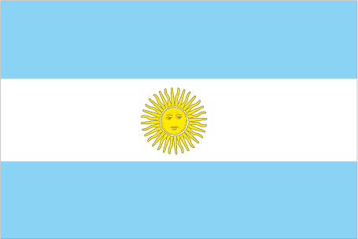  Argentina | Gaucho Grill  200 Pine Avenue, Long Beach 90802  Maro Wood Grill  1915 South Coast Hwy Laguna Beach, CA 92651  Empanadas To Go  12345 Mountain Ave. Chino, CA 91710  Empanada’s Place  3811 Sawtelle Blvd. Los Angeles CA 90066  Empanada’s Place  3011 Harbor Blvd. Costa Mesa, CA 92626  Rika’s Empanadas  150 S. Grand Ave, Glendora, CA 91741  Malbec Argentinean Cuisine  1001 E Green St. Pasadena, CA 91106  Lala’s Argentine Grill  7229 Melrose Ave. 90046  El Gaucho Meat Market  2715 Manhattan Beach Blvd. Redondo Beach, CA 90278  Grand Casino Bakeries  3826 Main St. Culver City, CA 90232  Carlitos Gardel  7963 Melrose Ave. Los Angeles, CA 90046  Nonna’s Empanadas  8579 W 3rd St. Los Angeles, CA 90048 | (562) 590-5000  www.gauchogrillusa.com  (949) 793-4044  www.marowoodgrill.com  (909) 591-1140  www.empanadastogo.net  (310) 391-0888  www.empanadasplace.com  (714) 825-0100  www.empanadasplace.com  (626) 914-3472  (626) 683-0550  www.malbeccuisine.com  (323) 934-6838  www.lalasgrill.com  (310) 297-2617  (310) 202-6969  www.grandcasinobakery.com  (323) 655-0891  www.carlitosgardel.com  (310) 385-0445  www.nonnasempanadas.com
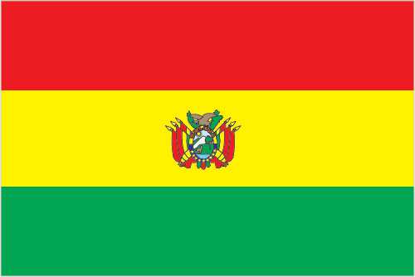  Bolivia | Bebas Restaurant  1909 E. Lincoln Ave. Anaheim, CA 92805  Bebas  6024 Hazetine Ave. Van Nuys, CA 91401 | (714) 535-0051  (818) 786-1511
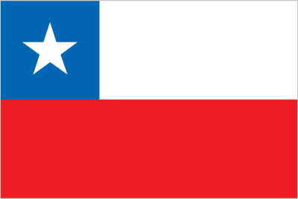  Chile | Rincón Chileno Deli  15418 Hawthorne Blvd, Lawndale 90260 | (310) 349-2091
Colombia | Sabor Colombiano  847 S. Union Ave, LA 90017  La Fonda Antioqueña  5125 Melrose Ave, LA 90004  Bambuco Colombian Grill  1478 Santa Fe Avenue, Long Beach 90813  El Portón Colombiano Restaurant  8863 Adams Ave. Huntington Beach, 92646  Donde Adela  1707 W. Chapman Ave. Orange CA 92868  La Colombiana  1640 N. El Camino Real, San Clemente, CA 90813  El Paisa  1640 Orange Ave. Long Beach, CA 90813  El Molinito  8535 W. Washington Blvd. Pico Rivera, CA 90660  La Fonda Paisa  6748 Passons Blvd. Pico Rivera, CA 90660  Mitze’s Kountry Kitchen  25381 Alicia Pkwy Ste C, Laguna Hills, CA 92653 | (213) 388-0150  http://www.saborcolombianola.com/  (323) 957-5164  http://www.lafondaantioquena.com/  (562) 435-8333  www.bambucogrill.com  (714) 968-6611  www.elportoncolombiano.com  (714)940-1701  www.comidacolombianaoc.com  (949) 441-7656  www.lacolombianaoc.com  (562) 333-8119  (562) 948-1828  (562) 948-4702  www.lafondapaisarestaurant.com  (949) 768-6499  www.mitzeskountrykitchen.com
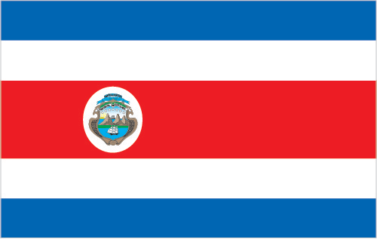  Costa Rica | Costa Rica Restaurant  2500 W Lincoln Ave #5, Anaheim, CA 92801 | (714) 527-2010  www.costaricarestaurantanaheim.com
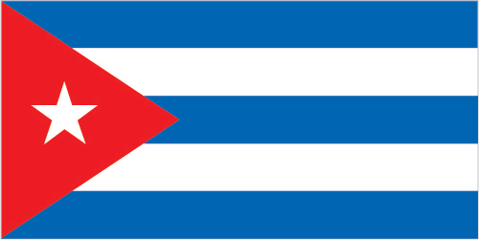  Cuba | Habana  2930 Bristol St. Costa Mesa, CA 92626  Bella Cuba  3940 S. Bristol St. Santa Ana, CA 92704  Moros Cuban Restaurant  380 N. Harbor Blvd. La Habra, CA 90631  Tropicana Bakery & Cuban Café  10218 Paramount Blvd. Downey, CA 90241  Porto’s Bakery & Café  8233 Firestone Blvd. Downey, CA 90241  Florida Restaurant  10025 Lakewood Blvd. Downey, CA 90240  Versailles Restaurant  10319 Venice Blvd. Los Angeles, CA 90034  Habana Vieja Cuban Cuisine & Café  1648 W. Carson St. Torrance, CA 90501  El Rincon Cubano  5434 Laurel Cyn Blvd. Valley Village, 91607  Habana Café  11402 Old River School Rd, Downey, 90241  Havana Mania  3615 Inglewood Ave. Redondo Bch, 90278  La Caridad Restaurant  2619 W Sunset Blvd. Los Angeles, CA 90026  Felix Continental Café  36 Plaza Square, Orange, CA 92866  El Cochinito Restaurant  3508 W Sunset Blvd. Los Angeles, CA 90026  El Colmao  2328 W Pico Blvd. Los Angeles, CA 90006 | (714) 556-0176  www.habanacostamesa.com  (714) 545-5711  www.bellacubarestaurant.com  (562) 694-4169  www.moroscubanrestaurant.com  (562) 806-8343  www.tropicanabakery.com  (562) 862-8888  www.portosbakery.com  (562) 869-7847  (310) 558-3168  www.versaillescuban.com  (310) 320-0935  (818) 763-6272  www.rinconcubanorestaurant.com  (562) 776-7251  www.habanacaferestaurant.com  (310) 725-9075  www.havanamania.com  (213) 484-0099  (714) 633-5842  www.felixcontinentalcafe.com  (323) 668-0737  (213) 386-6131
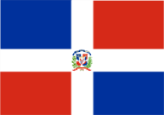  Dominican Republic | Mama Fina Dominican Restaurant  7931 E. Firestone Blvd. Downey, CA 90241 | (562) 867-8128  www.mamafinarestaurant.com
Ecuador  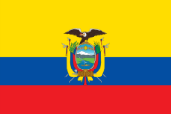 | Rinconcito Ecuatoriano  14607 Prairie Avenue, Lawndale, CA 90260  Jacky’s Ecuadorian Flavor  4035 W. 159th St. Lawndale, CA 90260  El Caserio  401 Silver Lake Blvd. Los Angeles, CA 90026 | (310) 973-1150  (310) 529-5390  (213) 273-8945  www.elcaseriola.com
El Salvador  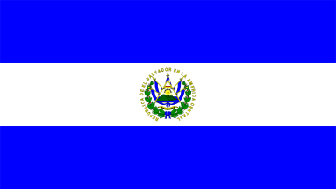 | Izalco Restaurant  300 West 5th St. Santa Ana, CA 92701  San Salvador Restaurant  16540 Harbor Blvd. Fountain Valley, 92708  Pupuseria San Sivar  1940 Harbor Blvd. Costa Mesa, CA 92627  Pupuseria Salvadoreña  1336 W Willow St. Long Beach, CA 90810  El Cafetal Salvadorian Restaurant  4929 Santa Monica Blvd. Los Angeles, CA 90029  El Carbonero Restaurant  803 S Main St. Santa Ana, CA 92701  Nancy’s Pupusería  8511 Knott Ave. Buena Park, CA 90620  El Curtido  16048 E. Gale Ave. Hacienda Heights, 91745  Myra’s Salvadorian Cuisine  7324 Florence Ave. Downey, CA 90240  Cuzcatlan Restaurant  1330 S. Magnolia Ave, Anaheim, CA.  Jaraguá  4493 Beverly Blvd. Los Angeles, CA 90004 | (714) 973-0554  www.izalco-restaurant.com  (714) 418-9610  (949) 650-2952  www.san-sivar.com/home  (562) 426-6004  (323) 660-2953  (714) 542-6653  (714) 995-2086  (626) 369-8004  (562) 806-3231  (714) 503-5814  (323) 661-1985  www.jaraguarestaurant.com
Guatemala  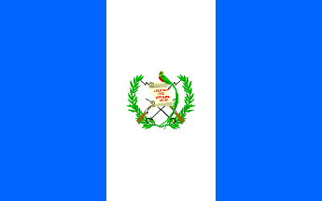 | Panaderia La Chapina  2230 W. Edinger Ave. Santa Ana, CA 92704  Puchica Guatemalan Bar & Grill  4523 Sepulveda Blvd. Sherman Oaks, CA 91403  Restaurante Rinconcito Guatemalteco  501 N Western Ave. Los Angeles, CA 90004  Amalia’s Restaurant  751 N. Virgil Ave. Los Angeles, CA 90029  Guatemala Restaurant  743 S. Union Ave. Los Angeles, CA 90017  Guatemalteca Bakery Restaurant  4770 Santa Monica Blvd. Los Angeles, CA 90029  Paseo Chapin  2220 W. 7th St. Los Angeles, CA 90057  Pan Victoria  2190 W. Washington Blvd. Los Angeles, CA 90018  Café Antigua Guatemala  5421 Santa Monica Blvd. Los Angeles, CA 90029 | (714) 437-9492  (818) 990-1011  www.puchicabarandgrill.com  (323) 463-6602  www.rinconcitoguatemalteco.com  (323) 644-1515  www.amaliarestaurant.com  (213) 483-4503  (323) 663-8307  (213) 385-7420  (323) 766-1499  (323) 465-0755
Honduras  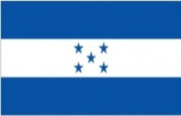 | Lempira Restaurant  4848 Hollywood Blvd. Los Angeles, 90027  Rincón Hondureño  1654 W. Adams Blvd. Los Angeles, 90007  Antojitos Bibi  2400 W 7th St. Los Angeles, CA 90057  La Casa Honduras  9131 S. Vermont Ave. Los Angeles, 90044  El Katracho Restaurant  14838 Burbank Blvd. Sherman Oaks, CA 91411  Honduras Kitchen  1909 E 4th St. Long Beach, CA 90802  Mi Tierra  2417 E. Anaheim St. Long Beach, CA 90804 | (323) 662-2927  (323) 734-9530  (213) 383-8595  (323) 777-1117  (818) 780-7044  www.elkatrachorestaurant.com  (562) 624-8849  www.hkhonduraskitchen.com  (562) 438-8866
Mexico  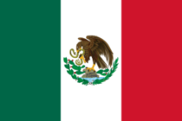 | La Huasteca  3150 E Imperial Hwy #100, Lynwood, 90262  Guelaguetza Restaurante  3014 W Olympic Blvd, Los Angeles, 90006  Casa Sanchez  4500 S. Centinela Ave, Los Angeles, 90066  Guisados  2100 E Cesar Chávez Ave, Los Angeles, CA 90033 | (310) 537-8800  www.lahuastecarestaurant.com  (213) 427-0608  www.ilovemole.com  (310) 397-9999  www.casa-sanchez.com  (323) 264-7201  www.guisados.co
Nicaragua  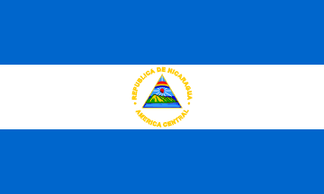 | Las Segovias Nicaraguan Restaurant  8014 Seville Ave. Huntington Park, CA 90255  El Gallito Market & Restaurant  12242 Valley Blvd. El Monte, CA 91732  Comedor Nicaragüense Camacho  2019 Venice Blvd. Los Angeles, CA 90006  LA 27  1830 W. Pico Blvd. Los Angeles, CA 90189  Restaurante Rincón Nicaragüense  2703 S. Vermont Ave. Los Angeles, CA 90007  La Adelita Food  1287 S. Union Ave. Los Angeles, CA 90015 | (323) 582-0096  (626) 442-1190  www.elgallitonicamexcocina.com  (323) 735-6272  (213) 387-2467  (323) 731-8149  (213) 487-0176
Panama
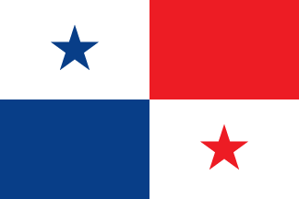

Paraguay
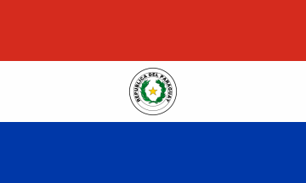

Peru  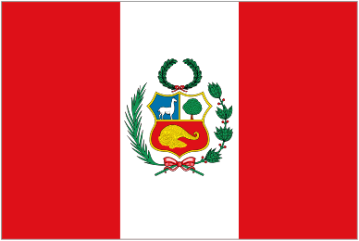 | Eqeko Peruvian Tapas  309 W 3rd St. Santa Ana, CA 92701  Inka Mama’s  3930 S. Bristol St. Santa Ana, CA 92704  Delicias Peruanas  24354 Muirlands Blvd. Lake Forest, 92630  Inka Wasi  40 Peninsula Ctr, Rolling Hills Estates, 90274  El Rocoto  1356 W. Artesia Blvd, Gardena, CA 90248  El Rocoto  11433 South St. Cerritos, CA 90703  Pollo a la Brasa  16527 S Vermont Ave, Gardena, CA 90247  Playa Blanca  413 Main Street, El Segundo, CA 90245,  Casa Inka  8610 Warner Ave. Fountain Valley, 92708  Inka Cantina  18279 Brookhurst St. Fountain Valley, 92708  Inka Grill  260 Bristol St. Costa Mesa, CA 92626  Inka Grill  23600 Rockfield Blvd. Lake Forest, CA 92630  Inka’s Restaurant  16277 Laguna Canyon Rd. Irvine, CA 92618  El Pollo Kri-ollo  1390 W. 6th St. Ste. 124, Corona, CA 92882  La Pollada Peruvian Grill  933 S. Euclid St. Anaheim, CA 92802  Ajo Limon  7035 Lincoln Ave. Buena Park, CA 90620  El Chicama Peruvian Restaurant  6959 Cerritos Ave. Stanton, CA 90680  Mario’s Peruvian Seafood Restaurant  15720 Imperial Hwy, La Mirada, CA 90638  Aji Peruvian Cuisine  2308 4th St. Long Beach, CA 90814  Peru Peru Grill  2415 W Lincoln Ave. Anaheim, CA 92801  Muelle Peruvian Cantina  7667 Center Ave. Huntington Bch, 92647  Aires del Perú  13008 Chapman Ave. Garden Grove, 92868  Nory’s Restaurant  23798 Mercury Rd. Lake Forest, CA 92730  Charo’s Peruvian Cuisine  7563 Carson St. Long Beach, CA 90808  Mr. Pollo  12563 Harbor Blvd. Garden Grove, 92842  El Pollo Imperial  5991 Atlantic Ave. Long Beach, CA 90805  Intiraymi Cuisine  23545 Palomino Dr. Diamond Bar, 91765  El Pollo Inka  1425 W Artesia Blvd. Gardena, CA 90248 | (714) 547-7868  www.eqeko.com  (714) 557-6262  www.inkamamas.com  (949) 472-4752  (310) 541-6900  (310) 768-8768  (562) 924-1919  (310) 715-2494  (310) 615-0979  (714) 847-7555  www.casainkarestaurant.com  (714) 965-4600  www.inkacantina.com  (714) 444-4652  www.inkagrill.org/welcome.html  (949) 587-9008  www.inkagrill.co  (949) 753-1276  www.inkasoc.com  (951) 427-3867  (714) 600-0730  (714) 229-1500  www.ajilimon.com  (714) 995-2510  www.chicamaonline.com  (562) 902-8299  (562) 439-8545  (714) 484-0024  www.peruperugrill.com  (714) 891-0123  www.muellehb.com  (714) 750-7343  www.airesdelperu.com  (949) 458-0318  (562) 627-0087  www.charosperucuisine.com  (714) 638-8896  (562) 612-3315  www.elpolloimperial.com  (909) 861-1200  (310) 516-7378  www.elpolloinka.com
Puerto Rico  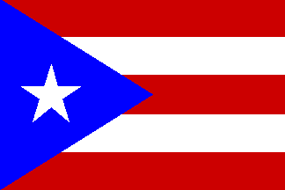 | Mofongos Comida Caribeña  5757 Lankershim Blvd. N. Hollywood, 91601  Señor Big Ed  5490 Lincoln Ave. Cypress CA 90630  San Juan BBQ  10203 Hole Ave. Riverside, CA 92503  La Puma Rosa  510 E Broadway, Long Beach, CA 90802 | (818) 754-1051  www.mofongosrestaurant.com  (714) 821-1290  (951) 588-6555  www.sanjuanbbq1.com  (323) 973-8358
Spain  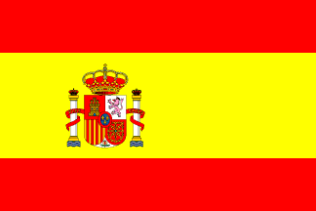 | Café Sevilla  140 Pine Ave. Long Beach, CA 90802  Churros Calientes  11521 Santa Monica Blvd. Los Angeles, CA 90029  El Cid Show Restaurante  4212 W Sunset Blvd. Los Angeles, CA 90029  La Paella  476 S. San Vicente Blvd. Los Angeles, 90048  Tinto Tapas España  7511 Santa Monica Blvd. West Hollywood, CA 90046  Viva Madrid!  225 Yale Ave, Claremont, CA 91711  Little Spain  6333 W 3rd St. Los Angeles, CA 90036  Pueblo (Tapas)  3321 Hyland Ave. Costa Mesa, CA 92626  Smoke.Oil.Salt (Catalan)  7274 Melrose Ave. Los Angeles, CA 90046  Olé Spain Delishop  136 W Macarthur Blvd. Santa Ana, 92707  Casa Córdoba  2331 Honolulu Ave. Montrose, CA 91020  Taberna Arros y Vi  1403 2nd St. Santa Monica, CA 90401  Manchego  2518 Main St. Santa Monica, CA 90405 | (562) 495-1111  www.cafesevilla.com  (424) 248-3890  www.churroscalientes.com  (323)668-0318  www.elsidla.com/flamencoshow.html  (323)951-0745  www.usalapaella.com  (323)512-3095  www.tintotapas.com  (909) 624-5500  www.vivamadrid.com  (323) 634-0633  (714) 340-5775  www.pueblotapas.com  (323) 930-7900  www.smokeoilsalt.com  (714) 966-1087  www.olespaindelishop.com  (818) 937-4445  www.casacordobba.us.com  (310) 393-3663  www.tabernala.com  (310) 450-3900  www.manchegosm.com
Uruguay

Venezuela  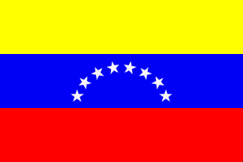 | Café Bolivar  1741 Ocean Park Blvd. Santa Monica, 90405  Mil jugos  320 W 5th St. Santa Ana, CA 92701  Café Caracas  239 E 5th St. Los Angeles, CA 90013  Coupa Café  419 N. Canon Dr. Beverly Hills, CA 90210  Amara Chocolate & Coffee  55 S Raymond Ave. Pasadena, CA 91105 | (310) 581-2344  www.cafebolivar.com  (714) 836-4601  www.miljugos.com  (213) 622-0863  (310) 385-0420  www.coupacafe.com  (626) 744-1765  www.amarachocolate.com

Diana Muñoz, COACH Foreign Language Project, 2015

