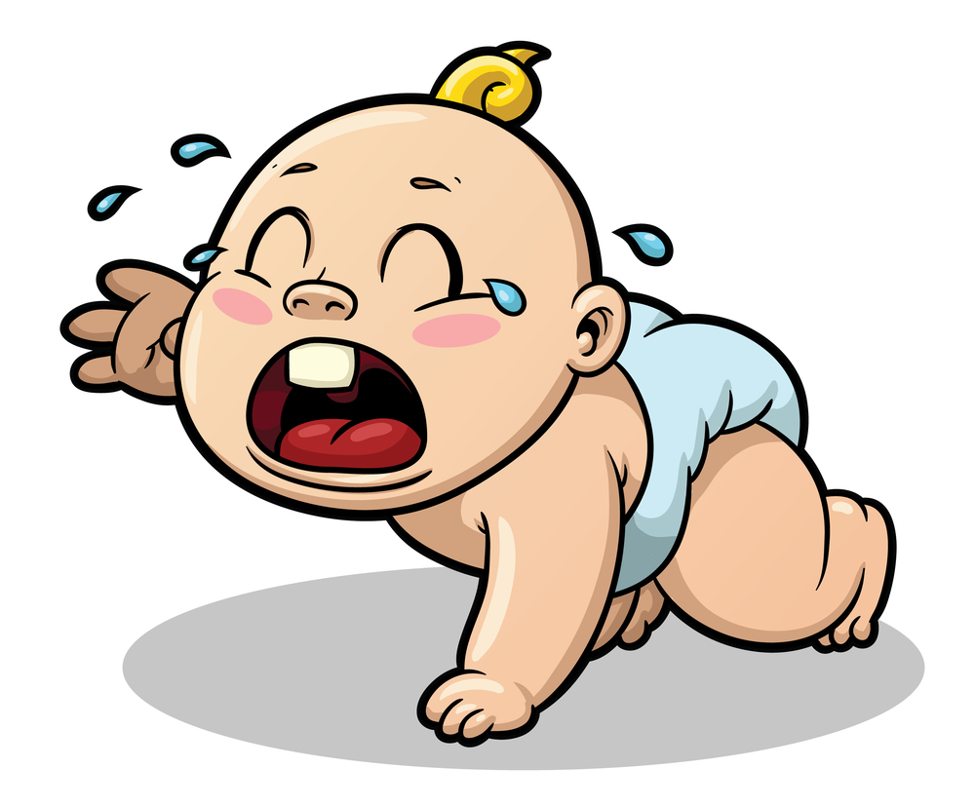
The Bad Baby Story

SKELETON

- There is a baby (There is a mom / dad) at the supermarket (Ralph’s).
- The mom / dad walks. (BUT) The baby runs.
- The baby is bad
- The mom says…
  - “Walk, baby, walk.”
  - “Stop baby”
  - “Sit down, baby.”

- The baby does NOT walk / stop / sit.
- The baby runs.
- The baby sits in the….fruit/cereal/chocolate (cognate).
- The baby laughs. The mom cries.
- The mom says “My baby is BAD.”
- The bad baby laughs and says “YES!”

READING

There are a two people: a mom and a baby at a supermarket. The mom walks in the market but the baby runs. The mom says “walk, baby, walk” but the baby doesn't walk. He runs fast. The mom says “baby, stop.” But the baby does not stop, he runs fast in circles in the supermarket. The mom says “bad baby. Sit down.” The baby stops. He doesn’t sit down. He laughs and runs to the fruit and sits in the fruit. The mother says “no baby, not in the fruit!” The baby sits in the fruit and laughs. The mother cries and says “My baby is bad.” The bad baby laughs and says…
“Yes, I am bad, very bad.”

A version of The Bad Baby Story by Jalen Waltman www.waltmania.com
adapted by Jason Fritze – jasonfritze@mac.com

