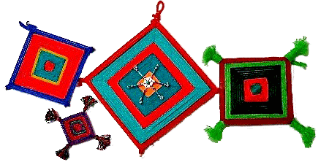
Ojos de Dios
A holiday activity for the classroom

Ojos de Dios are yarn weavings and spiritual objects for many indigenous groups. Their origin is believed to trace back to the Huichol Indians of central México, but they are created today in México and Bolivia, as well as the southwestern United States.

A quick internet search will show you elaborate, many-sided versions, but you can do a simple version with your classes using popsicle sticks and craft yarn. The accompanying PowerPoint contains photos and directions for weaving Ojos with your students.

MATERIALS NEEDED (purchased at Michael’s – they have a teacher discount with your school ID and also offer coupons)

- Popsicle sticks (available in boxes of 1000)
- Cheap craft yarn (buy variegated yarn – yarn that changes color – instead of solids)
- A glue gun and glue sticks
- Scissors

Before beginning, I advise preparing the popsicle sticks by gluing them together to form a cross. It’s also much easier if you pre-cut the yarn in lengths of about 4 yards. The label on the yarn package will tell you how many yards are in each skein (bundle) of yarn.

Before wrapping, have students number the sticks clockwise from 1 – 4 (see slide in PowerPoint)

This is a very quick project and can easily be completed in about 20 – 30 minutes. If you are interested in directions for more elaborate Ojos, check out these websites:

http://www.ojos-de-dios.com/jaysojodirections.html
http://www.wikihow.com/Make-an-Eye-of-God

Shari Kaulig, COACH Foreign Language Project, 2015

